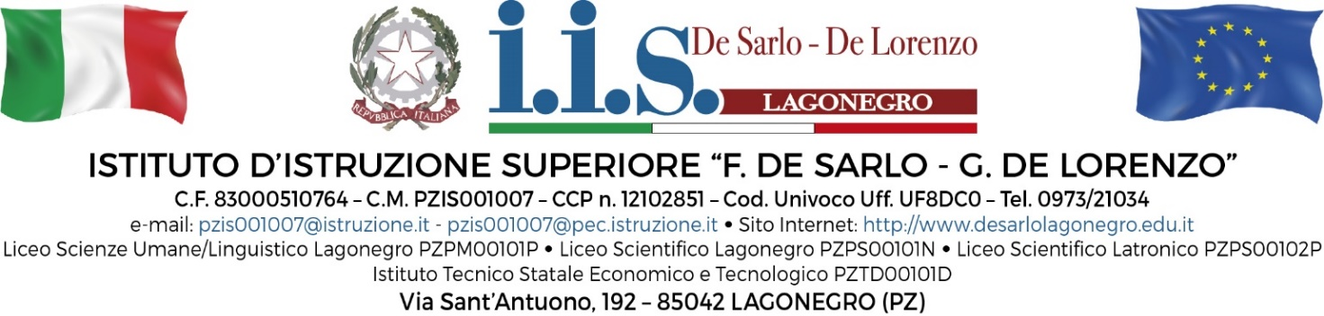
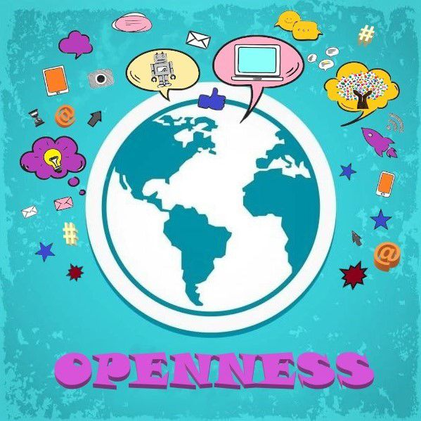
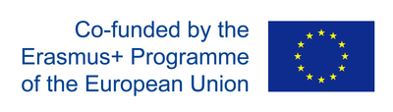

Erasmus+ learning programme for teachers’ activities provided by the invited expert:

Prof.ssa Jenni Decandia
School Oriveden Lukio - Orivesi Finland

Monday 20 November 2023
Timing | Activity afternoon with teacher “CLIL what is this?”
14:00-15:00 | Key principles to integrate digital technologies into teaching and learning
15:00-16:00 | Do’s and don’ts of digital technologies in teaching
Tuesday 21 November 2023
Timing | Activity afternoon with teachers
14:00-15:00 | Digital resources and tools to facilitate collaborative and self- directed learning
15:00-16:00 | Good digital practices on facilitating collaborative and self- directed learning
Wednesday 22 November 2023
Timing | Activity afternoon with teacher
14:00-15:00 | Digital tool to assess students
15:00-16:00 | Good practices on using digital tools
Thursday 23 November 2023
Timing | Activity afternoon with teachers
14:00-15:00 | How digital tools facilitate the analysis of students’ progress as well as teachers’ feedback
15:00-16:00 | Good practices on analysing students’ progress and on giving feedback by using digital tools
Friday 24 November 2023
Timing | Activity afternoon with teacher
14:00-15:00 | Empowering students and helping them to develop their digital skills
15:00-16:00 | Good practices on supporting students to develop their digital skills

