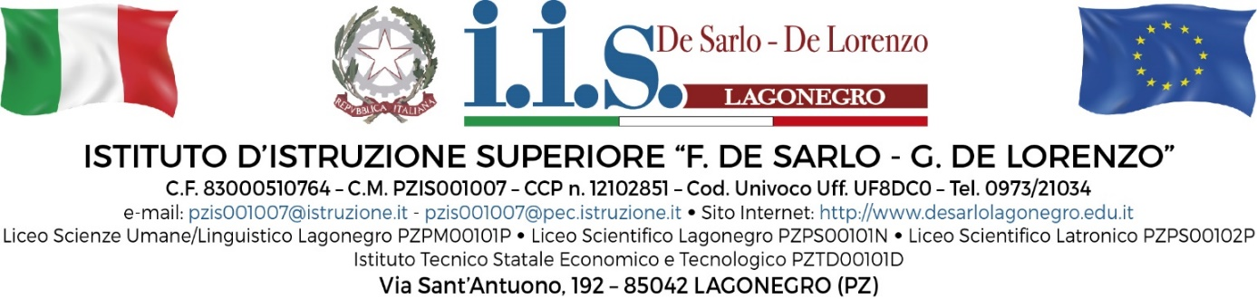
Erasmus+ learning programme for students’ activities provided by the invited expert:
Prof.ssa Jenni Decandia
School Oriveden Lukio - Orivesi Finland

Timetable
Monday 20 November 2023
Timing | Activities with students
9:00-10:00 | 5A LSU Environment: Blue school activities  Prof.ssa Papaleo Maria Teresa
10:00-11:00 | 5D LL Environment: Eco school activities  Prof. Marino
11:00-12:00 | 5E LL Environment: Unesco school activities  Prof.ssa Burla
Tuesday 21 November 2023
Timing | Activities with students
9:00-10:00 | 5E LL Citizenship: Wellbeing Academy  Prof.ssa Chiacchio
10:00-11:00 | 5A LSU Citizenship: Hello Teenagers! – Inclusion and participation Prof.ssa Mango
11:00-12:00 | 5D LL Citizenship: Young reporters for the environment  Prof.ssa Armentano
Wednesday 22 November 2023
Timing | Activities with students
9:00-10:00 | 5B LS Global issues: World in the year 2050  Prof.ssa Zaccaro L.
10:00-11:00 | 5D LS Global issues: World in the year 2050  Prof.ssa Siervo
11:00-12:00 | 5A LS Global issues: World in the year 2050  Prof.ssa Zaccara G.
Thursday 23 November 2023
Timing | Activities with students
9:00-10:00 | 5D LS Inter-cultural and heritage learning  Prof.ssa Napoli
10:00-11:00 | 5A LS Culture of peace and non-violence  Prof.ssa Napoli
11:00-12:00 | 5B LS Culture of peace and non-violence  Prof.ssa Zaccaro
Friday 24 November 2023
Timing | Activities with students
9:00-10:00 | 5B LS Green Teens News  Prof.ssa Francolino
10:00-11:00 | 5D LS Green Teens News  Prof.ssa Siervo
11:00-12:00 | 5A LS Green Teens News  Prof.Blasi
Saturday 25 November 2023
Timing | Activities with students
9:00-10:00 | 2E LSA Citizenship: Virtual citizenship lab  Prof.ssa Guerrera
10:00-11:00 | 2E LSA Lost in Europe – Digital road trip  Prof.ssa Gioia
11:00-12:00 | 2C LSA Citizenship: Virtual citizenship lab  Prof. Tulimieri
12:00-13:00 | 2C LSA Lost in Europe – Digital road trip  Prof.Tulimieri

LL: Liceo Linguistico
LSU : Liceo delle scienze umane
LS : Liceo Scientifico
LSA : Liceo delle Scienze Applicate

