Erasmus+ learning programme for group activities – INVITE EXPERT
Mobility ID: KA122-SCH - Short-term projects for mobility of learners and staff in school education
Project code: O.P.E.N.N.E.S.S. 2022-1-IT02-KA122-SCH-000071120

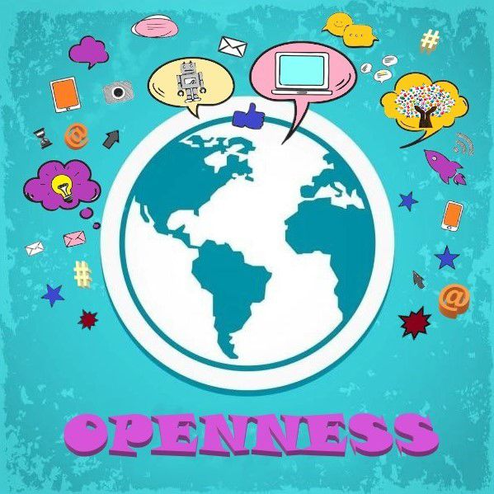
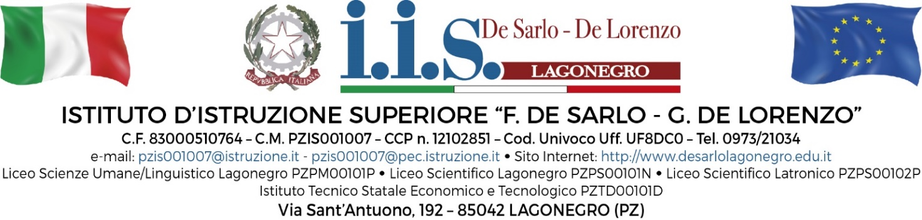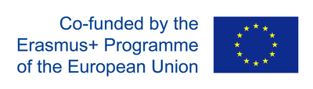

Erasmus+ learning programme provided by the invited expert:
Prof. Walther Rahbek
Hasseris Gymnasium &school- Denmark

Monday 13 November 2023
Timing | Activity afternoon with teacher “CLIL what is this?”
14:30-15:30 | A walk through the CLIL principles
15:30-16:30 | Your own experience with CLIL – does it work for you?
Tuesday 14 November 2023
Timing | Activity afternoon with teachers
14:30-15:30 | Lets plan a CLIL lecture – your own content and class
15:30-16:30 | Group discussions: Which outcome do we foresee?
Wednesday 15 November 2023
Timing | Activity afternoon with teacher
14:30-15:30 | Good examples and exercise in Power Point Presentations
15:30-16:30 | Presentation techniques – how to make your lecture exciting!
Thursday 16 November 2023
Timing | Activity afternoon with teachers
14:30-15:30 | My experience from CLIL?
15:30-16:30 | CLIL and differentiation in classroom
Friday 17 November 2023
Timing | Activity afternoon with teacher
14:30-15:30 | My experience from classroom in Denmark
15:30-16:30 | Other teaching experience

